Approved by RB Rail AS
Procurement Commission,
Date of decision 5 July 2022
(session minutes No 1)

CANDIDATE SELECTION REGULATION
for Competitive Procedure with Negotiation
Consolidated supply of railway ballast for Rail Baltica railway construction

(identification No: RBR 2022/14)

SUPPLIER QUALIFICATION



2022

TABLE OF CONTENTS
1. General information 3
2. information ABOUT the stage two of the Competition and the contract 5
3. Candidate 6
4. Selection criteria for the CANDIDATES 6
5. The rights of the CANDIDATE 16
6. Contents and form of the APPLICATION 17
7. encryption of the Application information 19
8. Submission of the application 19
9. Opening of applications 19
10. Verification of applications 19
11. Decision making, Announcement of results 21
12. The rights of the procurement commission 21
13. The obligations of the procurement commission 22
14. Annexes: 23
Annex No 1.1.: Application form for Lot No 1 24
Annex No 1.2.: Application form for Lot no 2 26
Annex No 1.3.: Application form for lot no 3 28
Annex No 1.4.: Application form for lot no 4 30
Annex No 1.5.: Application form for lot no 5 32
Annex No 1.6.: Application form for lot no 6 34
Annex No 2.1: General description of subject matter 36
ANNEX NO 2.2: TECHNICAL SPECIFICATION OF THE RAILWAY BALLAST……………………...39
Annex No 3: Entities on whose capabilities the Candidate relies to certify its compliance with qualification requirements 47
Annex No 4.1.: Experience of the Candidate (Lot No 1) 48
Annex No 4.2.: Experience of the Candidate (Lot No 2) 49
Annex No 4.3.: Experience of the Candidate (Lot No 3) 50
Annex No 4.4.: Experience of the Candidate (Lot No 4) 51
Annex No 4.5.: Experience of the Candidate (Lot No 5) 52
Annex No 4.6.: Experience of the Candidate (Lot No 6) 53
Annex No 5: Confirmation of Candidates Financial Standing 54

Regulation
- General information
  - Procurement Procedure: Competitive procedure with negotiation, which is organised in accordance with:

Section 8, Paragraph 6, Clause 3 of the Public Procurement Law of Latvia and Section 2.3. of the Republic of Latvia Cabinet Regulations No 107 “Tendering Procedures for Procurement Procedures and Design Contests”, effective on the day of publishing of the contract notice (hereinafter referred to as – Competition or competitive procedure with negotiation), because the procurement contract cannot be awarded without prior negotiations due to specific circumstances related to the nature, the complexity or the legal and financial structure of the procurement, or due to the risks related hereto. The Competition consists of two stages:
    - Stage One (qualification) – selection of the Candidates. During the selection of the Candidates the Procurement Commission shall select Candidates compliant with the requirements of the Regulations for the Selection of the Candidates for participation in Stage Two of the Competition.
    - Stage Two (proposals) – submission of initial proposal(s) of the qualified Candidates and negotiations, submission of final proposal(s) and awarding of Framework agreement. The Procurement Commission shall conduct assessment of the proposal(s) submitted by the Candidates and negotiations on initial and all further proposals. After the negotiations, the Procurement Commission shall request the Tenderers to submit their final proposals. The Procurement Commission shall verify compliance of the final proposal(s) with the requirements of the Regulation and determine the Tenderer, which is awarded the Framework agreement, through establishing of the criteria set to determine the most economically advantageous proposal. The Procurement Commission shall be entitled to make a decision not to organise negotiations and award the Framework agreement on the basis of the initial proposal(s) submitted by the Tenderers. The regulations for the undertaking of possible negotiations will be provided in the Stage Two procurement documents.
  - Procurement Identification Number: RBR 2022/14.
  - Applicable CPV code: 14212310-6 (Ballast).
  - The contracting entity is RB Rail AS, legal address: Kr. Valdemara iela 8 - 7, Riga LV-1010, Latvia (hereinafter – Contracting Authority). The Contracting Authority conducts this procurement for the benefit of the:
    - Ministry of Transport of the Republic of Latvia represented by “Eiropas Dzelzceļa līnijas” SIA;
    - The Implementing Body appointed by the Ministry of Transport and Communications of the Republic of Lithuania, AB LTG Infra;
    - Ministry of Economic Affairs and Communications of the Republic of Estonia represented by Rail Baltic Estonia OÜ.
  - Contact person of the Contracting Authority for this Competition: Elīna Saule, Procurement Specialist-lawyer, telephone No +371 26654433, e-mail address: ballast@railbaltica.org. Requests for information or additional explanations must be submitted solely through the E-Tenders system. Answers to the questions, explanations from the Contracting Authority and communication between Contracting Authority and Candidates are also provided through the E-Tenders system.
  - Candidate – supplier, which is registered in the Electronic Procurement System www.eis.gov.lv
and which has submitted an Application for Stage One of the Competition in the E-Tenders System which is subsystem of the Electronic Procurement System.
  - Tenderer – supplier, which is registered in the Electronic Procurement System and which has submitted a proposal(s) for Stage Two of the Competition in the E-Tenders System which is the subsystem of the Electronic Procurement System.
  - Application – the application submitted by the Candidate in Stage One of the Competition.
  - Procurement Commission – the Competition is conducted by the Procurement Commission established by the Contracting Authority.
  - Electronic Procurement System (E-Tenders System) – the electronic system used to carry out the procurement in the electronic form. The registration and connection to the system: www.eis.gov.lv.
  - Framework agreement (hereinafter also procurement contract or Contract) - an agreement between the contracting entities under Section 1.4. of the Regulation, including RB Rail AS as central purchasing body, and economic operators (awarded Tenderers) the purpose of which is to establish and characterise the procurement contracts to be concluded within a certain period of time and to provide for the provisions according to which such contracts will be concluded.
  - The subject-matter of the Competition – Consolidated supply of railway ballast for Rail Baltica railway construction. General description of the subject-matter of the Competition is included in Annex No 2 “General description of the subject matter” to the Regulation for the Selection of the Candidates. During the stage of the Selection of the Candidates, General description of the subject matter is given for informative purposes only. Detailed description of the subject-matter of procurement will be issued to the Candidates, which will be selected for participation in the Stage Two of the Competition.
  - The subject-matter of the Competition is divided into the following lots (value split indicative only):
    - Lot No 1: Supply of the railway ballast to Tallinn region in Estonia (hereinafter – Lot No 1) for the total estimated contract value 27 456 750 EUR without VAT;
    - Lot No 2: Supply of the railway ballast to Pärnu region in Estonia (hereinafter – Lot No 2) for the total estimated contract value 26 185 000 EUR without VAT;
    - Lot No 3: Supply of the railway ballast to Iecava region in Latvia (hereinafter – Lot No 3) for the total estimated contract value 27 921 750 EUR without VAT;
    - Lot No 4: Supply of the railway ballast to Skulte region in Latvia (hereinafter – Lot No 4) for the total estimated contract value 31 754 500 EUR without VAT;
    - Lot No 5: Supply of the railway ballast to Panevežys region in Lithuania (hereinafter – Lot No 5) for the total estimated contract value 26 921 000 EUR without VAT;
    - Lot No 6: Supply of the railway ballast to Kaunas region (Polish border - Kaunas - Vilnius) in Lithuania (hereinafter – Lot No 6) for the total estimated contract value 61 560 000 EUR without VAT.

The Candidate is entitled to submit the Application for one or several lots. All requirements established within this Regulation are applicable for all lots, unless specified otherwise in the respective Clause of Regulation.
  - Framework agreement duration: 84 months from the commencement day, with the possibility to extend the period of execution covering also the defects notification period and in accordance with the terms and conditions specified in regulatory enactments and the Framework agreement.
  - Delivery place: Estonia, Latvia, Lithuania in accordance with general description of subject-matter.
  - This Competition is carried out using the E-Tenders System which is a subsystem of the Electronic Procurement System https://www.eis.gov.lv/EKEIS/Supplier.
Suppliers apply for the Electronic Procurement System (if the Candidate is not registered in Electronic Procurement System) in State Regional Development Agency (please see information here http://www.railbaltica.org/procurement/e-procurement-system/).

This Regulation and all its annexes are freely available in the Contracting Authority’s profile in the E-Tenders System on the webpage https://www.eis.gov.lv/EKEIS/Supplier/Organizer/3001,

and the Internet site of the Contracting Authority https://www.railbaltica.org/tenders/.

Amendments to this Regulation and answers to Candidates’ questions shall be published on the E-Tenders System’s webpage https://www.eis.gov.lv/EKEIS/Supplier/Procurement/85750 and the Contracting Authority's Internet site https://www.railbaltica.org/tenders/. It is the Candidate’s responsibility to constantly follow the information published on the webpage and to take it into consideration in its Application.
  - The Competition is co - financed by the Connecting Europe Facility (CEF) and the state budget of Estonia, Latvia and Lithuania.
- information ABOUT the stage two of the Competition and the contract

  - During the Stage Two of the Competition the Procurement Commission in every lot will choose the most economically advantageous proposal according to criteria covering technical, financial and environmental aspects which comply with the requirements set in the documentation of the Stage Two of the Competition. Detailed criteria and methodology for the award of the most economically advantageous proposal will be specified in the documentation of the Stage Two of the Competition.
  - During the Stage Two of the Competition the Contracting Authority shall evaluate, inter alia, subcontractors, whose share of the Contract is equal to or exceeds 10% of the Contract price, of the Tenderer to whom the rights to conclude the Contract should be assigned. In case such subcontractors will comply with any of the exclusion grounds which are mentioned in Sections ‎4.1.‎2. to ‎4.1.‎8. and 4.1.13. the Contracting Authority shall request the Tenderer to change such subcontractor. If the Tenderer shall not submit documents about another subcontractor which complies with the selection criteria within 10 (ten) business days from the date when the request was issued or sent to the Tender, the Contracting authority shall exclude such Tenderer from further participation in the Competition.
  - The qualified Candidate, who will be invited to submit a proposal in the Stage Two of the Competition, will be obliged to submit a separate bid security for each lot for which the Tenderer has applied by submitting their proposal:

    - in the amount of 25 000,00 EUR (twenty five thousand euro and 0 cents) for the Lot No 1;
    - in the amount of 25 000,00 EUR (twenty five thousand euro and 0 cents) for the lot No 2;
    - in the amount of 25 000,00 EUR (twenty five thousand euro and 0 cents) for the lot No 3.
    - in the amount of 25 000,00 EUR (twenty five thousand euro and 0 cents) for the lot No 4.
    - in the amount of 25 000,00 EUR (twenty five thousand euro and 0 cents) for the lot No 5.
    - in the amount of 25 000,00 EUR (twenty five thousand euro and 0 cents) for the lot No 6.

For the avoidance of doubt – if a supplier submits a proposal for more than one lot, then each Lot shall have a separate proposal and each proposal must be accompanied by a valid bid security.
  - Conditions of the bid security will be provided in the Stage Two of the Competition.
  - Framework agreement will be based on the terms and conditions of the draft Framework agreement provided by the Contracting Authority in Stage Two of the Competition. The Framework agreement entered into as a result of the Competition will be co-financed from the financial resources of the Connecting Europe Facility (CEF).
  - The Tenderer to whom the rights to enter into Framework agreement will be awarded, will be obliged to provide the following securities (guarantees) in compliance with the terms of the Framework agreement:

    - Contract performance guarantee for each lot shall be provided upon signing of the contract for the value up to 10% from the Contract price and with the conditions to be specified in the Stage Two of the Competition.
    - Advance payment security submitted by the Tenderer in accordance with the provisions set in the particular conditions of the draft Framework agreement in the amount of the advance payment, to be paid, if such advance payment is foreseen under the Framework agreement;
    - other security(-ies), if any, foreseen under the provisions of the Framework agreement.
  - The Tenderer will be obliged to submit the securities provided for in the Framework agreement according to the provisions laid down in the Framework agreement and the security forms included in annexes thereto, if any, which will be included in the documentation of the Stage Two of the Competition. All costs for the securities to be submitted and insurance shall be covered by the Tenderer at its own expense.
  - Payments to the contractor will be made in accordance with the payment conditions specified in the draft Framework agreement, which will be included in the documentation of the Stage Two of the Competition.
  - Responsibility of the parties will be determined in accordance with the applicable laws and the Framework agreement. The Parties will duly perform their obligations undertaken in accordance with the Framework agreement and refrain from any activities, which may cause mutual harm or impede performance of the other party's obligations.
  - According to the:
- (LV) Section 11¹ of the Law on International Sanctions and National Sanctions of the Republic of Latvia,
- (EST) Law on International Sanctions of the Republic of Estonia and Sanctions established by Estonian Government,
- (LT) Civil code of the Republic of Lithuania and
The Law on Implementation of economic and other international sanctions of the Republic of Lithuania,

the Contracting Authority or contracting entities listed in Section 1.4. of Regulation shall be entitled to unilaterally withdraw from the performance of the Framework agreement, if the Framework agreement cannot be performed due to the fact that international or national sanctions, or sanctions determined by a Member State of the European Union or North Atlantic Treaty Organisation that affect significant financial and capital market interests have been imposed.
  - The liability of the parties shall be determined pursuant to the applicable laws of the respective country and the Contract. The parties shall properly fulfil their obligations undertaken under the Contract and shall refrain from any actions that may lead to damage to each other or that could impede the other party’s fulfilment of the obligations undertaken.
- Candidate

  - The Application can be submitted by:

    - A supplier, which is a legal or natural person and who complies with the selection criteria for the Candidates.
    - A group of suppliers (hereinafter also – Candidate, partnership) which complies with the selection criteria for Candidates:
- a group of suppliers who have formed a partnership for this particular Competition. In this case all the members of the partnership shall be listed in Annex 1 “Application form”. If it will be decided to award contracting rights to such partnership, then prior to concluding the Contract the partnership shall at its discretion either enter into a partnership agreement (within the meaning of Civil Law of the Republic of Latvia, Sections 2241 till 2280) and shall submit one copy of this agreement to the Contracting Authority or establish a general or limited partnership (within the meaning of Commercial Law of the Republic of Latvia, Chapter IX and X) and notify the Contracting Authority in writing.
- an established and registered partnership (a general partnership or a limited partnership, within the meaning of Commercial Law of the Republic of Latvia, Chapter IX and X) which complies with the selection criteria for Candidates.

- Selection criteria for the CANDIDATES

  - Exclusion grounds (will be verified according to Section 10.2.3. of Regulation)

The Contracting Authority shall exclude the Candidate from further participation in the Competition in any of the following circumstances:
No | Requirement | Documents to be submitted
 | Within previous 3 (three) years before submission of the Application the Candidate or a person who is the Candidate’s management board or supervisory board member, person with representation rights or a procura holder, or a person who is authorised to represent the Candidate in operations in relation to a branch, has been found guilty of or has been subjected to coercive measures for committing any of the following criminal offences by such a public prosecutor’s order regarding punishment or a court judgement that has entered into force and may not be challenged and appealed:  a) establishment, management of, involvement in a criminal organisation or in an organised group included in the criminal organisation or other criminal formation, or participation in criminal offences committed by such an organisation,  b) bribe-taking, bribery, bribe misappropriation, intermediation in bribery, unauthorised participation in property transactions, taking of prohibited benefit, commercial bribing, unlawful claiming of benefits, accepting and providing of benefits, trading influences,  c) fraud, misappropriation or money-laundering,  d) terrorism, terrorism funding, formation or organization of terrorist group, travelling for terrorism purposes, justification of terrorism, calling to terrorism, terrorism threats or recruiting and training a person in performance of acts of terrorism,  e) human trafficking,  f) evasion of taxes and similar payments. | No obligation to submit documents (except cases stipulated in Section 10.3. of Regulation), unless specifically requested by the Procurement Commission according to Article 42 of the Public Procurement Law.
 | It has been detected that on the last day of the term for submitting Applications (Stage One) or on the day when a decision has been made on possible granting of rights to conclude the procurement contract (Stage Two), the Candidate has tax debts in Latvia or a country where it has been incorporated or is permanently residing, including debts of mandatory state social insurance contributions exceeding 150 euro in total in any of the countries. | No obligation to submit documents unless specifically requested by the Procurement Commission according to Article 42 of the Public Procurement Law.
 | Candidate’s insolvency proceedings have been announced, the Candidate’s business activities have been suspended, the Candidate is under liquidation. | No obligation to submit documents (except cases stipulated in Section 10.3. of Regulation), unless specifically requested by the Procurement Commission according to Article 42 of the Public Procurement Law.
 | A person who drafted the procurement procedure documents (Contracting Authority’s official or employee), Procurement Commission member or expert is related to the Candidate, or is interested in selection of some Candidate, and the Contracting Authority cannot prevent this situation by measures that cause less restrictions on Candidates. A person who drafted the procurement procedure documents (Contracting Authority’s official or employee), Procurement Commission member or expert is presumed to be related to the Candidate in any of the following cases:  a) If he or she is a current and/or an ex-employee, official, shareholder, procura holder or member of a Candidate or a subcontractor which are legal persons and if such relationship with the legal person was terminated within the last 24 (twenty four) months.  b) If he or she is the father, mother, grandmother, grandfather, child, grandchild, adoptee, adopter, brother, sister, half-brother, half-sister or spouse (hereinafter – relative) of a Candidate’s or subcontractor’s, which is a legal person, shareholder who owns at least 10% of the shares in a joint-stock company, shareholder in a limited liability company, procure holder or an official.  c) If he or she is a relative of a Candidate or a subcontractor which is a natural person.  If the Candidate is a partnership, consisting of natural or legal persons, a relation to the Candidate is presumed also if a person who drafted the procurement procedure documents (Contracting Authority’s official or employee), Procurement Commission member or expert is related to a member of a partnership in any of the above-mentioned ways. | No obligation to submit documents, unless specifically requested by the Procurement Commission according to Article 42 of the Public Procurement Law.
 | The Candidate has an advantage that limits competition in the procurement procedure if it or its related legal person consulted the Contracting Authority or otherwise was involved in preparing the Competition, and the advantage cannot be prevented by less restrictive measures, and the Candidate cannot prove that its or its related legal person’s participation in preparing the procurement procedure documents does not restrict competition. | No obligation to submit documents (except cases stipulated in Section 10.3. of Regulation), unless specifically requested by the Procurement Commission according to Article 42 of the Public Procurement Law.
 | Within the previous 12 (twelve) months before last day of the term for submitting Applications (Stage One) by such a decision of a competent authority or a court judgment which has entered into force and may not be challenged and appealed, the Candidate has been found guilty of violating competition laws manifested as a horizontal cartel agreement, except for the case when the relevant authority, upon detecting violation of competition laws, has released the Candidate from a fine or has decreased the fine for cooperation within a leniency program. | No obligation to submit documents (except cases stipulated in Section 10.3. of Regulation), unless specifically requested by the Procurement Commission according to Article 42 of the Public Procurement Law.
 | Within the previous 3 (three) years before last day of the term for submitting Applications (Stage One) by such a decision of a competent authority or a court judgment, or a public prosecutor’s order regarding punishment, which has entered into force and may not be challenged and appealed, the Candidate has been found guilty of a violation manifested as employment of one or more persons who do not possess the required employment permit or if it is illegal for such persons to reside in a Member State of the European Union. | No obligation to submit documents (except cases stipulated in Section 10.3. of Regulation), unless specifically requested by the Procurement Commission according to Article 42 of the Public Procurement Law.
 | Within the previous 12 (twelve) months before last day of the term for submitting Applications (Stage One) by such a decision of a competent authority or a court judgment or a public prosecutor’s order regarding punishment which has entered into force and may not be challenged and appealed, the Candidate has been found guilty of a violation manifested as employment of a person without a written employment contract, by failing within the term specified in regulatory enactments to submit an informative employee declaration regarding this person, which must be submitted about persons, who start working. | No obligation to submit documents (except cases stipulated in Section 10.3. of Regulation), unless specifically requested by the Procurement Commission according to Article 42 of the Public Procurement Law.
 | The Candidate has provided false information to prove its compliance with provisions of this Section or has not provided the required information at all. | No obligation to submit documents, unless specifically requested by the Procurement Commission according to Article 42 of the Public Procurement Law.
 | The Candidate is a registered offshore company (legal person) or offshore association of persons (consortium). | No obligation to submit documents, unless specifically requested by the Procurement Commission according to Article 42 of the Public Procurement Law.
 | The owner or shareholder (with more than 25% of share capital) of the Candidate, which is registered in Republic of Latvia, is a registered offshore company (legal person) or offshore association of persons. | No obligation to submit documents, unless specifically requested by the  Procurement Commission according to Article 42 of the Public Procurement Law.
 | Person on whose capabilities Candidate is relying, is a registered offshore company (legal person) or offshore association of persons. | No obligation to submit documents, unless specifically requested by the Procurement Commission according to Article 42 of the Public Procurement Law.
 | The subcontractors indicated by the Candidate whose share of contract is equal to or exceeds 10% of the Contract price, is a registered offshore company (legal person) or offshore association of persons. | No obligation to submit documents, unless specifically requested by the Procurement Commission according to Article 42 of the Public Procurement Law in Stage Two of this Competition.
 | International or national sanctions or substantial sanctions by the European Union (EU) or the North Atlantic Treaty Organization (NATO) Member State affecting the interests of the financial and capital market has been imposed to the:  - Candidate or a person who is the Candidates’s management board or supervisory board member, beneficial owner,[ person with representation rights or a procura holder, or a person who is authorised to represent the Candidate in operations in relation to a branch,  - member of the partnership or a person who is the partnership’s management board or supervisory board member, beneficial owner[2], person with representation rights or a procura holder (if the Candidate is a partnership),  and such sanctions can affect the execution of the Procurement contract. | No obligation to submit documents, unless specifically requested by the Procurement Commission according to the Article 11¹. of the Law on International Sanctions and National Sanctions of the Republic of Latvia in Stage Two of this Competition.
 | Exclusion grounds described in Section 4.1.1. to 4.1.8. shall be applied also to each member of the partnership if the Candidate is a partnership, to each person on whose capabilities the Candidate is relying to meet qualification requirements.  Exclusion grounds described in Section 4.1.2. to 4.1.8. shall be applied also to each subcontractor indicated by the Tenderer in Stage Two of this competition whose share of work is equal to or exceeds 10% of the total Contract price. | No obligation to submit documents (except cases stipulated in Section 10.3. of Regulations), unless specifically requested by the Procurement Commission according to Article 42 of the Public Procurement Law.  No obligation to submit documents, unless specifically requested by the Procurement Commission according to Article 42 of the Public Procurement Law in Stage Two of this Competition.
  - Legal standing and suitability to pursue the professional activity
No | Requirement | Documents to be submitted
 | The Candidate or all members of the partnership (if the Candidate is a partnership) or persons on whose capabilities the Candidate is relying must be registered in the Registry of Enterprises or Registry of Inhabitants, or an equivalent register in their country of residence, if the legislation of the respective country requires registration of natural or legal persons. | - For a Candidate, each member of the partnership (if the Candidate is a partnership), a person on whose capabilities the Candidate is relying, which is a legal person registered in Latvia, the Contracting Authority shall verify the information itself in publicly available databases.  - For a Candidate, each member of the partnership (if the Candidate is a partnership), a person on whose capabilities the Candidate is relying, which is a natural person – a copy of an identification card or passport.  - For a Candidate, each member of a partnership (if the Candidate is a partnership), a person on whose capabilities the Candidate is relying, which is a legal person registered abroad (with its permanent place of residence abroad) – a copy of a valid registration certificate or a similar document issued by a foreign authority in charge of the registration of legal persons in the country of their residence wherefrom at least the fact of registration, beneficial owners, legal representatives (officials) and procura holders (if any) can be determined.

  - Economic and financial standing
No | Requirement | Documents to be submitted
 | The Candidate’s average financial turnover within the last 3 (three) financial years (2019, 2020, 2021) is not less than:  - 10 000 000 EUR if the Candidate applies for the Lot No 1;  - 10 000 000 EUR if the Candidate applies for the Lot No 2;  - 10 000 000 EUR if the Candidate applies for the Lot No 3;  - 10 000 000 EUR if the Candidate applies for the Lot No 4;  - 10 000 000 EUR if the Candidate applies for the Lot No 5;  - 20 000 000 EUR if the Candidate applies for the Lot No 6.  If the Candidate is a partnership (consortium), the turnover of all members of a partnership together shall comply with the above requirement.  If the Candidate applies for several lots, the Candidate’s or all members’ of the partnership together (if the Candidate is a partnership), average financial turnover within the last 3 (three) financial years (2019, 2020, 2021) is not less than sum of average financial turnover values set for each lot for which the Candidate has applied by submitting Application.  In the event the average financial turnover of a limited liability member of a limited partnership (within the meaning of Latvian Commercial Law, Chapter X) exceeds its investment in the limited partnership, the average financial turnover shall be recognised in the amount of the investment in the limited partnership.  In the case the Candidate or a member of a partnership (if the Candidate is a partnership) has operated in the market for less than 3 (three) years, the requirement shall be met during the Candidate’s actual operation period.  In the case the previous three financial years of particular Candidate differs from financial years (2019, 2020, 2021) stated in Regulations or the financial report isn’t available, financial turnover shall be indicated for previous three financial years where financial report is available. | - Filled in and signed Annex No 5 (by the Candidate).  - Audited or self-approved by the Candidate (only in case if audited yearly financial report is not required by the law of the country of residence of the supplier) yearly reports for financial years 2019, 2020, 2021 showing the turnover of the Candidate and each member of the partnership on whose abilities the Candidate is relying to certify it`s financial and economic performance and who will be financially responsible for the execution of the Contract (if the Candidate is a partnership). If yearly report for financial year 2021 is not available yet, Candidate has to submit other documents showing the annual financial turnover of the Candidate for financial year 2021.  - For a limited partnership (within the meaning of Latvian Commercial Law, Chapter X) an additional document evidencing the amount of the investment by the limited liability partner (the partnership agreement or a document with a similarly binding legal effect).  - If an Application is submitted by a partnership, the Candidate shall indicate the member of the partnership on whose capabilities the Candidate is relying to certify it`s financial and economic performance and who will be financially and economically responsible for fulfilment of the Contract including this information in the agreement of cooperation (or letter of intention to enter into agreement) stipulated in Clause 6.4.3.

  - Technical and professional ability
No | Requirement | Documents to be submitted
 | For the Candidates applying for Lot No 1:  Within the last 5 (five) years before the date of submission of the Application (2021, 2020, 2019, 2018, 2017 and 2022 until the submission of the Application) in any continuous 12 months period the Candidate has performed at least 1 (one) or several contract/-s/ supply/-s of aggregates with all of the following parameters:  - produced in accordance with one or several following standards EN 13450, EN 13043, EN 12620, EN 13242, EN 13285 or equivalent (to prove the required amount of the supply, Candidate may combine several EN standards);  - compatible with CE (Conformité Européenne) marking requirements;  - produced according to AVCP level 2+ as minimum.  for one or several clients for construction of infrastructure projects (roads, earthworks, concrete structures, etc.) for the total amount of 50 000 tons.  For the Candidates applying for Lot No 2:  Within the last 5 (five) years before the date of submission of the Application (2021, 2020, 2019, 2018, 2017 and 2022 until the submission of the Application) in any continuous 12 months period the Candidate has performed at least 1 (one) or several contract/-s/ supply/-s of aggregates with all of the following parameters:  - produced in accordance with one or several following standards EN 13450, EN 13043, EN 12620, EN 13242, EN 13285 or equivalent (to prove the required amount of the supply, Candidate may combine several EN standards);  - compatible with CE (Conformité Européenne) marking requirements;  - produced according to AVCP level 2+ as minimum.  for one or several clients for construction of infrastructure projects (roads, earthworks, concrete structures, etc.) for the total amount of 50 000 tons.  For the Candidates applying for Lot No 3:  Within the last 5 (five) years before the date of submission of the Application (2021, 2020, 2019, 2018, 2017 and 2022 until the submission of the Application) in any continuous 12 months period the Candidate has performed at least 1 (one) or several contract/-s/ supply/-s of aggregates with all of the following parameters:  - produced in accordance with one or several following standards EN 13450, EN 13043, EN 12620, EN 13242, EN 13285 or equivalent (to prove the required amount of the supply, Candidate may combine several EN standards);  - compatible with CE (Conformité Européenne) marking requirements;  - produced according to AVCP level 2+ as minimum.  for one or several clients for construction of infrastructure projects (roads, earthworks, concrete structures, etc.) for the total amount of 50 000 tons.  For the Candidates applying for Lot No 4:  Within the last 5 (five) years before the date of submission of the Application (2021, 2020, 2019, 2018, 2017 and 2022 until the submission of the Application) in any continuous 12 months period the Candidate has performed at least 1 (one) or several contract/-s/ supply/-s of aggregates with all of the following parameters:  - produced in accordance with one or several following standards EN 13450, EN 13043, EN 12620, EN 13242, EN 13285 or equivalent (to prove the required amount of the supply, Candidate may combine several EN standards);  - compatible with CE (Conformité Européenne) marking requirements;  - produced according to AVCP level 2+ as minimum.  for one or several clients for construction of infrastructure projects (roads, earthworks, concrete structures, etc.) for the total amount of 50 000 tons.  For the Candidates applying for Lot No 5:  Within the last 5 (five) years before the date of submission of the Application (2021, 2020, 2019, 2018, 2017 and 2022 until the submission of the Application) in any continuous 12 months period the Candidate has performed at least 1 (one) or several contract/-s/ supply/-s of aggregates with all of the following parameters:  - produced in accordance with one or several following standards EN 13450, EN 13043, EN 12620, EN 13242, EN 13285 or equivalent (to prove the required amount of the supply, Candidate may combine several EN standards);  - compatible with CE (Conformité Européenne) marking requirements;  - produced according to AVCP level 2+ as minimum.  for one or several clients for construction of infrastructure projects (roads, earthworks, concrete structures, etc.) for the total amount of 50 000 tons.  For the Candidates applying for Lot No 6:  Within the last 5 (five) years before the date of submission of the Application (2021, 2020, 2019, 2018, 2017 and 2022 until the submission of the Application) in any continuous 12 months period the Candidate has performed at least 1 (one) or several contract/-s/ supply/-s of aggregates with all of the following parameters:  - produced in accordance with one or several following standards EN 13450, EN 13043, EN 12620, EN 13242, EN 13285 or equivalent (to prove the required amount of the supply, Candidate may combine several EN standards);  - compatible with CE (Conformité Européenne) marking requirements;  - produced according to AVCP level 2+ as minimum.  for one or several clients for construction of infrastructure projects (roads, earthworks, concrete structures, etc.) for the total amount of 100 000 tons.  For the Candidates applying for several lots:  If Candidate applies for several lots, then requirements of experience for supplied quantities of individual lots needs to be combined. | - Filled in and signed Annex No 4.1. – 4.6., containing description of contracts/ supplies performed by the Candidate.  - Procurement Commission is entitled to request from Candidate to submit the references from Clients to verify the information indicated in the Annex No 4.1.-4.6 (no obligation to submit references, only in case it will be requested by Procurement Commission).  - Candidate shall submit the documents to prove compliance with Clause 4.4.2. a) b) and c).  To prove the compliance Candidate may submit e.g. declaration of Performance (DoP) of the supplied aggregate(s), document confirming compatibility to CE (Conformité Européenne) of the aggregate(s), Factory Production Control (FPC) Certificate of the supplied aggregate(s) according to one or several following standards EN 13450, EN 13043, EN 12620, EN 13242, EN 13285 or equivalent proving compliance with AVCP level 2+ as minimum or any other document proving compliance with Clause 4.4.2.  - If the Candidate has submitted the documents of conformity to equivalent standard, Candidate has to submit a copy of certificate from respective institutions accredited in accordance with the procedures laid down in the regulatory enactments of Member State of the European Union proving that the standard is equivalent to one or several following standards EN 13450, EN 13043, EN 12620, EN 13242, EN 13285.
  - For the fulfilment of the specific Contract, in order to comply with the selection requirements for the Candidates relating to the economic and financial standing and technical and professional ability, the Candidate may rely upon the capabilities of other persons, regardless of the legal nature of their mutual relationship. In this case:
    - The Candidate indicates:
      - in the Application all persons upon whose capabilities it relies by filling in the table which is attached as Annex No 3, fills necessary information in E-Tenders system

and
      - proves to the Contracting Authority that the Candidate will have available all the necessary resources for the fulfilment of the Contract, by submitting a signed confirmation or agreement on cooperation and/or passing of resources to the Candidate between such persons and the Candidate. The confirmations and agreements on cooperation and passing of resources can be replaced by the Candidate with any other type of documents with which the Candidate is able to prove that the necessary resources will be available to the Candidate and will be used during the term of fulfilment of the Contract.
    - Documents on cooperation and passing of resources have to be sufficient to prove to the Contracting Authority that the Candidate will have the ability to fulfil the Contract, as well as that during the validity of the Contract the Candidate will in fact use the resources of such person upon whose capabilities the Candidate relies.
    - The Contracting Authority shall require establishing joint and several liability for the execution of the Contract between the members of a partnership (if the Candidate is a partnership) on whose financial and economic capabilities the partnership is relying and who will be financially and economically responsible for the fulfilment of the Contract or between the Candidate and any other person on whose financial and economic capabilities the Candidate is relying to meet requirements regarding financial and economic standing defined in Regulations and who will be financially and economically responsible for the fulfilment of the Contract.
  - The Candidate, in order to certify that it complies with the selection criteria for Candidates, may submit the European Single Procurement Document (hereinafter - ESPD) as initial proof. This document must be submitted for the Candidate and for each person upon whose capabilities the Candidate relies, but if the Candidate is a partnership – for each member thereof. The Candidate may fill in the European single procurement document at the Internet webpage http://espd.eis.gov.lv/ (Electronical procurement system of Latvia).
- The rights of the CANDIDATE
  - The supplier can request additional information regarding the Regulation Additional information can be requested in writing, by sending it to the Procurement Commission electronically using the E-Tenders System. Additional information must be requested in a timely fashion, so that the Procurement Commission can provide a response no later than 6 (six) days prior to the deadline for submitting Applications. The Procurement Commission shall provide a response within 5 (five) business days from the day of receipt of the request.
  - If the Contracting Authority receives the necessary information about the Candidate directly from a competent institution, through data bases or other sources and the Candidate’s submitted information differs from the information obtained by the Contracting Authority, the Candidate in question has the right to submit evidence to prove the correctness of the information the Candidate has submitted, if the information obtained by the Contracting Authority does not conform to the factual situation.
  - If a Candidate believes that its rights have been violated or such violation is possible due to possible violation of the laws of the European Union or other laws, the Candidate has the right to submit a complaint to the Procurement Monitoring Bureau according to the procedure stipulated in the Public Procurement Law of Latvia regarding the Candidate selection requirements, technical specifications or other requirements relating to this Competition, or relating to the activities of the Contracting Authority or the procurement commission during the Competition.
  - The Supplier covers all expenses, which are related to the preparation of an Application and its submission to the Contracting Authority and the Contracting Authority shall not be liable for any expenses incurred by any Supplier in relation with their participation in the procurement procedure. The submitted Applications are not returned to the Candidate, unless specifically envisaged in the Regulation.
- Contents and form of the APPLICATION
  - Application must be submitted electronically in E-Tenders subsystem of the Electronic Procurement System (https://www.eis.gov.lv/EKEIS/Supplier/ProcurementProposals/85750) in accordance with the following options for the Candidate:
    - by using the available tools of E-Tender subsystem, filling the attached forms of the E-Tender subsystem for this procurement procedure;
    - by preparing and filling the necessary electronic documents outside the E-Tenders subsystem and attaching them to the relevant requirements (in this situation, the Candidate takes responsibility for the correctness and compliance of the forms to requirements of documentation and form samples);
    - by encrypting electronically prepared Application outside subsystem of E-Tenders with data protection tools, provided by third parties, and protection with electronic key and password (in this situation, the Candidate takes responsibility for the correctness and compliance of the forms to the requirements of such documentation and form samples as well as ensuring the capability for the Contracting Authority to open and read the document).
  - During preparation of the Application, the Candidate shall comply with the following:
    - Application (documents mentioned in below in Section 6.4.) must be filled in a separate electronic document, in line with the forms (if provided) attached to the procurement process of the E-Tenders subsystem in a Microsoft Office 2010 (or later) format and attached to the designated part of the procurement procedure;
    - upon submission, the Candidate signs the Application with a secure electronic signature and time-seal or with an electronic signature provided by the Electronic Procurement System. The Candidate can use a secure electronic signature and time-seal and sign their application form separately.
  - The Application (its parts, if signed separately) are signed by an authorised person, including their authorisation document (e.g. power of attorney) expressis verbis stating the authorisations to sign, submit and otherwise manage the Application.
  - The following documents shall be included in the Application:
No | Document | Corresponding section in E-Tenders system (https://www.eis.gov.lv/EKEIS/Supplier/) where document shall be uploaded
 | Filled application form in accordance with Annex No 1.1. – 1.6. | Selection requirements
 | Documents confirming right of signature (representation):  A document confirming the right of signature (representation) of the representative of the Candidate or each member of a partnership (if Candidate is a partnership) who has signed Application for this Competition and any other document (e.g. partnership agreement, agreement on cooperation, letter of intent etc.) included in the Application.  A document confirming the right of signature (representation) of the representative of the person on whose capabilities the Candidate is relying to meet qualification criteria stipulated in Regulation and who has signed any documents (agreement on corporation, letter of intent etc.) included in Application. | Other requirements
 | Documents confirming establishment of partnership (consortium)  If an Application is submitted by a partnership, the Application shall include an agreement (or letter of intent to enter into agreement or any similar document) signed by all members of the partnership on the participation in the Competition, which:  - lists responsibilities of each and every partnership member and a joint commitment to fulfil the Framework Agreement;  - authorises one key member to sign the Application and other documents, to receive and issue orders on behalf of the partnership members, and with whom all payments will be made. | Other requirements
 | Information and documents (including documents, but not limited to, according to Section 4.2. – 4.4.), confirming compliance of the Candidate with the selection criteria for the Candidates or the corresponding ESPD (if applicable) | Selection requirements/ Other requirements
 | Information and documents relating to the entities on whose capabilities the Candidate is relying (according to Section 4.6. of Regulation) (If applicable) | Other requirements
 | Information and documents according to Section 10.3. (if applicable) | Other requirements

  - For each lot separate Application shall be submitted including all documents stipulated in Section 6.4. of Regulations, meaning that each Lot requires a separate, standalone and complete Application.
  - The Application must be submitted in a written form, in accordance with this Regulation, in English or Latvian language. If the Application is submitted in Latvian language, then upon a request by the Procurement Commission the Candidate shall provide a translation in English language within the deadline requested by the Contracting Authority’s Procurement Commission. If the Application is submitted in English language, upon a request by the Procurement Commission the Candidate shall provide a translation in Latvian language within the deadline requested by the Contracting Authority’s Procurement Commission.
  - The Application may contain original documents or their derivatives (e.g. copies). In the Application or in the reply to a request of the Procurement Commission the Candidate shall submit only such original documents which have legal force. For the document to gain legal force it has to be issued and formatted in accordance with the Law on Legal Force of Documents and Law on Electronic Documents of the Republic of Latvia, but public documents issued abroad shall be formatted and legalised in accordance with the requirements of the Document Legalization Law. When submitting the Application, the Candidate has the right to certify the correctness of all submitted documents’ derivatives and translations with one certification.
  - The Application must be signed using an electronic signature according to the requirements indicated in 6.2.2. of this Regulation.
  - Applications submitted after the expiry of the deadline for the submission of Applications shall not be reviewed.
- encryption of the Application information
  - The E-Tender system ensures the first level encryption of the information provided in the Application documents.
  - If the Candidate applied additional encryption to the information in the Application (according to Section 7.1.), the Candidate has to provide the Contracting Authority’s Procurement Commission representative listed in Section 1.5. with electronic key with the password to unlock the information not later than the deadline of the Application submission.
- Submission of the application
  - Application (documents referred to in the Section 6.4.) shall be submitted electronically using the tools offered by the E-Tenders system available at https://www.eis.gov.lv/EKEIS/Supplier by 26 August 2022 before 14:00 o'clock (Time Zone EEST (Eastern European Winter Time), Riga, Latvia).
The Candidate may recall or amend its submitted Application before the expiry of the deadline for the submission of Applications by using the tools provided in the E-Tenders System.
  - Only Applications submitted to the E-Tenders System and within the time indicated in Clause 8.1. will be accepted and evaluated for participation in the procurement procedure. Any Application submitted outside the E-Tenders system and within the time indicated in Clause 8.1. will be declared as submitted in a non-compliant manner and will not participate in the procurement procedure.
- Opening of applications
  - The opening of Applications will be held in the E-Tenders system on 26 August 2022 at 14:00 o’clock (Time Zone EEST (Eastern European Summer Time), Riga, Latvia) during the open meeting. It is possible to follow the opening of submitted Applications online in the E-Tenders System.
  - The Applications are opened by using the tools offered by the E-Tenders system, the public information of the Applications shall be published in the E-Tenders System.
  - The information regarding the Candidate, the time of Application submission and other information that characterises the Application is generated at the opening of the Applications by the E-Tenders system and written down in the Application opening sheet, which shall be published in the E-Tenders System and the Contracting Authority’s webpage.
- Verification of applications
  - The Contracting Authority’s Procurement Commission verifies whether the submitted Applications comply with the requirements of this Regulation. If the Application does not comply with some of the requirements of this Regulation, the Procurement Commission decides on the possibility of further evaluation of the Application.
  - The Contracting Authority’s Procurement Commission:
    - verifies whether all documents according to Section 6.4. are included in Application.
    - verifies whether the Candidate complies with the Candidate selection requirements specified in Section 4.2. – 4.4. of the Regulation.
    - According to Article 42 of the Public Procurement Law verifies whether the exclusion grounds stipulated in Section 4.1. – 4.1.12. (Article 42, Paragraph 1 of the Public Procurement Law) are applicable to the qualified Candidates (including persons on whose capabilities the Candidate is relying to meet qualification requirements) and which may be invited to submit proposal in Stage Two of this Competition.
  - If the Candidate is subject to any of the exclusion grounds under Section 4.1.1 and 4.1.3. – 4.1.8., the Candidate shall indicate this fact in Application (Annex No 1) and provide explanations and evidences regarding the reimbursement of the damage caused or an agreement on the reimbursement of the damage caused, cooperation with the investigating authorities and the technical, organisational or personal management measures taken to demonstrate their reliability and prevent recurrence of the same and similar cases in the future.
  - If the Candidate doesn’t submit explanations and evidences, Contracting Authority shall exclude the Candidate from participating in the procurement procedure as compliant to the exclusion grounds stipulated in Sections 4.1.1. and 4.1.3. – 4.1.8.
  - Contracting authority shall evaluate the measures taken by the Candidate, member of the partnership (if the Candidate is a partnership) and evidences thereof, taking into account the severity of the criminal offence or infringement and the specific circumstances. The Contracting authority may request from the competent authorities in the relevant field of criminal offence or infringement concerned opinions whether the measures taken by the Candidate are sufficient to restore reliability and to prevent the same or similar cases in the future. The opinion shall not be requested if it is already available for the Contracting authority or the Candidate has submitted an opinion of the relevant authority in the field of criminal offence or infringement regarding the sufficiency of the measures taken by the relevant Candidate for the restoration or reliability and for the prevention of the same and similar cases in the future.
  - If the Contracting authority considers the measures taken to be sufficient to restore reliability and prevent similar cases in the future, Contracting authority shall take a decision not to exclude the relevant Candidate from participating in the procurement procedure. If the measures taken are insufficient, the Contracting authority shall take a decision to exclude the Candidate from further participating in the procurement procedure.
  - The Contracting Authority shall request the Candidate to change person on whose capabilities the Candidate is relying to meet qualification requirements for the Candidates stipulated in Regulation if such person is subject to any of exclusion grounds reffered in Section 4.1.1. – 4.1.8. and 4.1.12. If the Candidate will not submit documents about another person on whose capabilities the Candidate is relying to meet qualification requirements which complies with the selection criteria within 10 (ten) business days from the date when the request was issued or sent to the Candidate, the Contracting authority shall exclude such Candidate from further participation in the Competition.
  - If the Candidate has failed to submit some of the documents which shall be submitted according to the Regulation (including evidences required by the Contracting authority in order to verify non-existence of exclusion grounds) or the contents of the submitted documents do not comply with the Regulation, the Procurement Commission decides to exclude the Candidate from further participation in the Competition.
  - Notices and other documents which are issued by Latvian competent institutions in cases referred to check of non-existence of exclusion grounds, are accepted and recognised by the Procurement Commission, if they are issued no earlier than 1 (one) month prior to submission thereof or if the notice contains a shorter validity term. Notices and other documents, which are issued by foreign competent institutions in cases referred to check of non-existence of exclusion grounds, are accepted and recognized by the Procurement Commission, if they are issued no earlier than 6 (six) months prior to submission thereof or if the notice contains a shorter validity term. The Candidate must verify the latter. This rule does not apply to fact of registration supporting documents, copies of ID cards, passports, marriage certificates or documents certifying economic standing of the Candidate.
  - If the documents, with which a Candidate registered or permanently residing abroad (outside Latvia) can certify its compliance with the requirements of Section 4.1. (Exclusion grounds) , are not issued or these documents are insufficient, such documents can be replaced with an oath or, if the regulatory enactments of the country in question do not allow for an oath, - with a certification by the Candidate or by another person mentioned in Section 4.1. before a competent executive governmental or judicial institution, a sworn notary or a competent organisation of a corresponding industry in their country of registration (permanent residence).
  - Only those Candidates who have been qualified, will be invited to submit the proposal in the Stage Two of the Competition.
- Decision making, Announcement of results
  - The Contracting Authority’s Procurement Commission selects the Candidates in accordance with the set selection criteria for Candidates, verifies the compliance of the Applications with the requirements stipulated in the Regulation.
  - In accordance the Cabinet Regulations of Latvia No 508 “Procedures for the planning and implementation of identification, security measures and operational continuity of critical infrastructure, including European critical infrastructure”, the Procurement commission is entitled to send information on Candidates who meet the requirements of the Regulations to the Latvian State Security Service for inspection, before approving the results of the first stage of the Competition and/or before awarding the contract rights in second stage of the Competition. In the event of a negative conclusion of the Candidate by the Latvian State Security Service, the Procurement commission will exclude it from the Competition.
  - Within 3 (three) business days from the date of the decision about the selection of the Candidates, the Procurement Commission informs all Candidates (to the refused Candidate the reasons for refusing its Application as well) about the decision made by sending the information electronically and keeping the evidence of the date and mode of sending the information, as well as about the deadline by which the Candidate may submit a complaint as foreseen in the Section 5.
  - If only 1 (one) Candidate within one lot complies with all the Candidate selection requirements, the Procurement Commission makes the decision to terminate the public procurement procedure in particular lot.
  - If the public procurement procedure is terminated, then within 3 (three) business days of the termination, the Procurement Commission simultaneously informs all the Candidates of all the reasons why the Competition procedure was terminated and informs about the deadline within which a Candidate may submit an complaint to the Institutions referred to in the Section 5.
  - When informing of the results, the Procurement Commission has the right not to disclose specific information if it may infringe upon public interests or if the Candidate’s legal commercial interests or the conditions of competition would be violated.
- The rights of the procurement commission
  - For the purpose of undertaking the procurement exercise, the Contracting Authority establishes a Procurement Commission, in accordance with its applicable procurement policy and the applicable Latvian Public Procurement Law. The Procurement Commission and the Supplier/ Candidate exchange information in writing in English or Latvian language (accompanied by a translation in English), using E-Tenders system. For the avoidance of doubt, unless specifically stated otherwise, all laws, acts and regulations under which this procurement exercise is undertaken, belong to the jurisdiction of the Republic of Latvia.
  - The Procurement Commission has the right to demand at any stage of the Competition that the Candidate submits all or part of the documents which certify the Candidate’s compliance to the requirements for the selection of Candidates. The Procurement Commission does not demand such documents or information which are already at its disposal or is publicly available free of charge. At the request of the Procurement Commission, the Candidate must specify the address and method of access to the public database.
  - If the Candidate submits document derivatives (e.g. copies) and the authenticity of the submitted document derivation is in doubt, the Procurement Commission can demand that the Candidate shows the original documents.
  - During the qualitative selection of Candidates, the Procurement Commission has the right to demand that information included in the Application to participate in Competition is clarified.
- The obligations of the procurement commission
  - The Procurement Commission ensures that the process of the Competition procedure is appropriately documented.
  - The Procurement Commission ensures free and direct electronic access to the Competition procedure documents in the E-Tenders system available at https://www.eis.gov.lv/EKEIS/Supplier/Procurement/85750 and at the Contracting Authority's Internet webpage https://www.railbaltica.org/tenders/.
  - If an interested supplier has requested additional information via the E-Tender system, the Procurement Commission provides a response via the E-Tender system within 5 (five) business days, but not later than 6 (six) days before the deadline for submitting Application’s. The Contracting Authority publishes this information on the E-Tenders system’s webpage and on the Contracting Authority's Internet webpage https://www.railbaltica.org/tenders under the section of the respective Competition procedure, indicating the question asked.
  - If the Contracting Authority has amended the Competition procedure documents, it publishes this information on the E-Tenders system’s webpage https://www.eis.gov.lv/EKEIS/Supplier/Procurement/85750 and at the Contracting Authority's Internet webpage https://www.railbaltica.org/tenders/, where Competition procedure documents are available, no later than 1 (one) day after the notification regarding the amendments have been submitted to the Procurement Monitoring Bureau for publication.
  - The exchange and storage of information in the E-Tenders system is carried out in such a way that all data included in the Applications is protected and the Contracting Authority can check the content of the Applications only after the expiration of the deadline for their submission. During the time period between the day of the submission of Applications until the moment of opening thereof the Contracting Authority does not disclose any information regarding the existence of other Applications. During the period of Candidate assessment until the moment of the announcement of the results of the Candidate selection the Contracting Authority does not disclose information regarding the assessment process.
  - The Procurement Commission assesses the Candidates and their submitted Applications based on the Latvian Public Procurement Law, this Regulation on competitive procedure with negotiations, as well as any other applicable regulatory enactments.
  - If the Procurement Commission determines that the information included in the submitted documents about the Candidate, its subcontractors and persons upon whose capabilities the Candidate is relying is unclear or incomplete, the Procurement Commission demands that the Candidate or a competent institution clarifies or expands the information included in the Application. The deadline for the submission of the necessary information is determined proportionally to the time which is required to prepare and submit such information. If the Procurement Commission has demanded to clarify or expand upon the submitted documents, but the Candidate has not done this in accordance with the requirements stipulated by the Procurement Commission, the Procurement Commission is under no obligation to repeatedly demand that the information included in these documents be clarified or expanded upon and the Contracting Authority’s procurement commission evaluates Applications based on the information available in the such Applications.
  - The Procurement Commission prepares the invitation to the Stage Two of the Competition consisting of the Regulations of the Stage Two of the competitive procedure with negotiations, the Technical Specification and the draft Contract and sends it to the selected Candidates that have been qualified for the Stage Two of the competitive procedure with negotiations.

- Annexes:
  - – 1.6. Application form;
  - General description of the subject matter;
  - Technical Specification;
- Entities on whose capabilities the Candidate relies to certify its compliance with qualification requirements;
  - – 4.6. Forms for indicating the experience of the Candidate “Experience of the Candidate”;
- Confirmation of Candidates Financial and Economic standing.

Annex No 1.1.
to the Regulation
for competitive procurement procedure
with negotiation No RBR 2022/14
“Consolidated supply of railway ballast for
construction of Rail Baltica railway line”

Annex No 1.1.: Application form for Lot No 1

[letterhead of the Candidate’s company]
2022.___._______
No____________
APPLICATION FOR PARTICIPATION IN THE competitive procurement procedure with negotiation
“Consolidated supply of railway ballast for Rail Baltica railway construction”, No RBR 2022/14 (lot No 1 – Supply of the railway ballast to Tallinn region in Estonia)
Name of the Candidate or members of the partnership if Candidate is a partnership
Registration number of the Candidate or members of the partnership
VAT payer registration number
Legal address
Actual address
Bank
Bank account (IBAN)
Bank code (SWIFT)
telephone number | e-mail
Contact person of the Candidate: name, surname, position
- We confirm participation in the Lot No 1 (Supply of the railway ballast to Tallinn region in Estonia) of the Competition organised by the RB Rail AS “Consolidated supply of railway ballast for construction of Rail Baltica railway line” No RBR 2022/14;

- (Only if applicable according to Section 10.3. of Regulation): Informs that the following persons comply with the following exclusion grounds:
Name of the entity (person) | Exclusion ground and brief description of the violation
[●]
[●]
- We confirm that the Regulation for the Competition is clear and understandable, we do not have any objections and complaints and in the case of granting the right to enter into the Stage Two of the Competition as well as granting rights to enter into a contract we shall undertake to fulfil all conditions of this Regulation.
- Guarantees that all information and documents provided are true.
- We meet the criteria of (please mark):
□ a small □ medium □ other

sized enterprise as defined in the Article 2 of the Commission Recommendation of 6 May 2003 concerning the definition of micro, small and medium-sized enterprise.

Signature: ______________________________
Date: [date of signing]
Name: [name of the representative of the Candidate]
Position: [position of the representative of the Candidate]

Annex No 1.2.
to the Regulation
for competitive procurement procedure
with negotiation No RBR 2022/14
““Consolidated supply of railway ballast for
construction of Rail Baltica railway line”

Annex No 1.2.: Application form for Lot no 2

[letterhead of the Candidate’s company]
2022.___._______
No____________
APPLICATION FOR PARTICIPATION IN THE competitive procurement procedure with negotiation
“Consolidated supply of railway ballast for Rail Baltica railway construction”, No RBR 2022/14 (lot No 2 – Supply of the railway ballast to Pärnu region in Estonia)
Name of the Candidate or members of the partnership if Candidate is a partnership
Registration number of the Candidate or members of the partnership
VAT payer registration number
Legal address
Actual address
Bank
Bank account (IBAN)
Bank code (SWIFT)
telephone number | e-mail
Contact person of the Candidate: name, surname, position
- We confirm participation in the Lot No 2 (Supply of the railway ballast to Pärnu region in Estonia) of the Competition organised by the RB Rail AS “Consolidated supply of railway ballast for Rail Baltica railway construction” No RBR 2022/14;

- (Only if applicable according to Section 10.3. of Regulation): Informs that the following persons comply with the following exclusion grounds:
Name of the entity (person) | Exclusion ground and brief description of the violation
[●]
[●]
- We confirm that the Regulation for the Competition is clear and understandable, we do not have any objections and complaints and in the case of granting the right to enter into the Stage Two of the Competition as well as granting rights to enter into a contract we shall undertake to fulfil all conditions of this Regulation.
- Guarantees that all information and documents provided are true.
- We meet the criteria of (please mark):
□ a small □ medium □ other

sized enterprise as defined in the Article 2 of the Commission Recommendation of 6 May 2003 concerning the definition of micro, small and medium-sized enterprise.

Signature: ______________________________
Date: [date of signing]
Name: [name of the representative of the Candidate]
Position: [position of the representative of the Candidate]

Annex No 1.3.
to the Regulation
for competitive procurement procedure
with negotiation No RBR 2022/14
“Consolidated supply of railway ballast for
construction of Rail Baltica railway line”

Annex No 1.3.: Application form for lot no 3

[letterhead of the Candidate’s company]
2022.___._______
No____________
APPLICATION FOR PARTICIPATION IN THE competitive procurement procedure with negotiation
“Consolidated supply of railway ballast for Rail Baltica railway construction”, No RBR 2022/14 (lot no 3 - Supply of the railway ballast to Iecava region in Latvia)
Name of the Candidate or members of the partnership if Candidate is a partnership
Registration number of the Candidate or members of the partnership
VAT payer registration number
Legal address
Actual address
Bank
Bank account (IBAN)
Bank code (SWIFT)
telephone number | e-mail
Contact person of the Candidate: name, surname, position
- We confirm participation in the Lot No 3 (Supply of the railway ballast to Iecava region in Latvia) of the Competition organised by the RB Rail AS “Consolidated supply of railway ballast for Rail Baltica railway construction” No RBR 2022/14;

- (Only if applicable according to Section 10.3. of Regulation): Informs that the following persons comply with the following exclusion grounds:
Name of the entity (person) | Exclusion ground and brief description of the violation
[●]
[●]
- We confirm that the Regulation for the Competition is clear and understandable, we do not have any objections and complaints and in the case of granting the right to enter into the Stage Two of the Competition as well as granting rights to enter into a contract we shall undertake to fulfil all conditions of this Regulation.
- Guarantees that all information and documents provided are true.
- We meet the criteria of (please mark):
□ a small □ medium □ other

sized enterprise as defined in the Article 2 of the Commission Recommendation of 6 May 2003 concerning the definition of micro, small and medium-sized enterprise.

Signature: ______________________________
Date: [date of signing]
Name: [name of the representative of the Candidate]
Position: [position of the representative of the Candidate]

Annex No 1.4.
to the Regulation
for competitive procurement procedure
with negotiation No RBR 2022/14
“Consolidated supply of railway ballast for
construction of Rail Baltica railway line”

Annex No 1.4.: Application form for lot no 4

[letterhead of the Candidate’s company]
2022.___._______
No____________
APPLICATION FOR PARTICIPATION IN THE competitive procurement procedure with negotiation
“Consolidated supply of railway ballast for Rail Baltica railway construction”, No RBR 2022/14 (lot no 4 - Supply of the railway ballast to Skulte region in Latvia)
Name of the Candidate or members of the partnership if Candidate is a partnership
Registration number of the Candidate or members of the partnership
VAT payer registration number
Legal address
Actual address
Bank
Bank account (IBAN)
Bank code (SWIFT)
telephone number | e-mail
Contact person of the Candidate: name, surname, position
1. We confirm participation in the Lot No 4 (Supply of the railway ballast to Skulte region in Latvia) of the Competition organised by the RB Rail AS “Consolidated supply of railway ballast for Rail Baltica railway construction” No RBR 2022/14;
2. (Only if applicable according to Section 10.3. of Regulation): Informs that the following persons comply with the following exclusion grounds:
Name of the entity (person) | Exclusion ground and brief description of the violation
[●]
[●]
3.We confirm that the Regulation for the Competition is clear and understandable, we do not have any objections and complaints and in the case of granting the right to enter into the Stage Two of the Competition as well as granting rights to enter into a contract we shall undertake to fulfil all conditions of this Regulation.
- Guarantees that all information and documents provided are true.
- We meet the criteria of (please mark):
□ a small □ medium □ other

sized enterprise as defined in the Article 2 of the Commission Recommendation of 6 May 2003 concerning the definition of micro, small and medium-sized enterprise.

Signature: ______________________________
Date: [date of signing]
Name: [name of the representative of the Candidate]
Position: [position of the representative of the Candidate]

Annex No 1.5.
to the Regulation
for competitive procurement procedure
with negotiation No RBR 2022/14
“Consolidated supply of railway ballast for
construction of Rail Baltica railway line”

Annex No 1.5.: Application form for lot no 5

[letterhead of the Candidate’s company]
2022.___._______
No____________
APPLICATION FOR PARTICIPATION IN THE competitive procurement procedure with negotiation
“Consolidated supply of railway ballast for Rail Baltica railway construction”, No RBR 2022/14 (lot no 5 - Supply of the railway ballast to Panevežys region in Lithuania)
Name of the Candidate or members of the partnership if Candidate is a partnership
Registration number of the Candidate or members of the partnership
VAT payer registration number
Legal address
Actual address
Bank
Bank account (IBAN)
Bank code (SWIFT)
telephone number | e-mail
Contact person of the Candidate: name, surname, position
1. We confirm participation in the Lot No 5 (Supply of the railway ballast to Panevežys region in Lithuania) of the Competition organised by the RB Rail AS “Consolidated supply of railway ballast for Rail Baltica railway construction” No RBR 2022/14;

2.(Only if applicable according to Section 10.3. of Regulation): Informs that the following persons comply with the following exclusion grounds:
Name of the entity (person) | Exclusion ground and brief description of the violation
[●]
[●]
3.We confirm that the Regulation for the Competition is clear and understandable, we do not have any objections and complaints and in the case of granting the right to enter into the Stage Two of the Competition as well as granting rights to enter into a contract we shall undertake to fulfil all conditions of this Regulation.
4.Guarantees that all information and documents provided are true.
5.We meet the criteria of (please mark):
□ a small □ medium □ other

sized enterprise as defined in the Article 2 of the Commission Recommendation of 6 May 2003 concerning the definition of micro, small and medium-sized enterprise.

Signature: ______________________________
Date: [date of signing]
Name: [name of the representative of the Candidate]
Position: [position of the representative of the Candidate]

Annex No 1.6.
to the Regulation
for competitive procurement procedure
with negotiation No RBR 2022/14
“Consolidated supply of railway ballast for
construction of Rail Baltica railway line”

Annex No 1.6.: Application form for lot no 6

[letterhead of the Candidate’s company]
2022.___._______
No____________
APPLICATION FOR PARTICIPATION IN THE competitive procurement procedure with negotiation
“Consolidated supply of railway ballast for Rail Baltica railway construction”, No RBR 2022/14 (lot no 6 - Supply of the railway ballast to Kaunas region (Polish border - Kaunas - Vilnius) in Lithuania
Name of the Candidate or members of the partnership if Candidate is a partnership
Registration number of the Candidate or members of the partnership
VAT payer registration number
Legal address
Actual address
Bank
Bank account (IBAN)
Bank code (SWIFT)
telephone number | e-mail
Contact person of the Candidate: name, surname, position
1.We confirm participation in the Lot No 6 (Supply of the railway ballast to Kaunas region (Polish border - Kaunas - Vilnius) in Lithuania) of the Competition organised by the RB Rail AS “Consolidated supply of railway ballast for Rail Baltica railway construction” No RBR 2022/14;

2.(Only if applicable according to Section 10.3. of Regulation): Informs that the following persons comply with the following exclusion grounds:
Name of the entity (person) | Exclusion ground and brief description of the violation
[●]
[●]
3.We confirm that the Regulation for the Competition is clear and understandable, we do not have any objections and complaints and in the case of granting the right to enter into the Stage Two of the Competition as well as granting rights to enter into a contract we shall undertake to fulfil all conditions of this Regulation.
4.Guarantees that all information and documents provided are true.
5.We meet the criteria of (please mark):
□ a small □ medium □ other

sized enterprise as defined in the Article 2 of the Commission Recommendation of 6 May 2003 concerning the definition of micro, small and medium-sized enterprise.

Signature: ______________________________
Date: [date of signing]
Name: [name of the representative of the Candidate]
Position: [position of the representative of the Candidate]

Annex No 2.1
to the Regulation
for competitive procurement procedure
with negotiation No RBR 2022/14
“Consolidated supply of railway ballast for
construction of Rail Baltica railway line”

Annex No 2.1: General description of subject matter

- Introduction to Rail Baltica project
Rail Baltica is a joint project of three EU Member States – Estonia, Latvia and Lithuania – and concerns the developing of a fast conventional double-track 1435 mm gauge electrified and ERTMS equipped railway line with overall length of 870 km on the route from Tallinn through Pärnu (EE), Riga (LV), Panevėžys (LT), Kaunas (LT) to the Lithuania/Poland state border (including a Kaunas – Vilnius spur) with a speed of 249km/h.
Railway line for both passenger and freight transport shall be TSI compliant and interoperable with the TEN-T Network in the rest of Europe and competitive in terms of quality with other modes of transport in the region.
Rail Baltica is to become a part of the EU TEN-T North Sea – Baltic Core Network Corridor, which links Europe’s largest ports of Rotterdam, Hamburg and Antwerp – through the Netherlands, Belgium, Germany and Poland – with the three Baltic States, further connecting to Finland via the Gulf of Finland short sea shipping connections with a future fixed link possibility between Tallinn and Helsinki. Furthermore, the North Sea – Baltic Corridor crosses with the Baltic-Adriatic Corridor in Warsaw, paving the way for new supply chain development between the Baltic and Adriatic seas, connecting the Baltics with the hitherto inadequately accessible Southern European markets.
The contracting authority RB Rail AS (hereinafter - RBR) was established by the Republics of Estonia, Latvia and Lithuania, via state-owned holding companies, to coordinate the development and construction of the fast-conventional standard gauge railway line on the North Sea – Baltic TEN-T Core Network Corridor (Rail Baltica II) linking three Baltic states with Poland and the rest of the EU. The main technical parameters are in full compliance with TSI INF (COMMISSION REGULATION (EU) No 1299/2014) consonant they are detailed in Design Guidelines. The key design criteria to follow are (non-exhaustive list):
- Double track, mixed passenger and freight traffic line, design speed on the main track 249 km/h;
- Axle load 25 t;
- Rolling stock gauge SEc
- Distance between track centres at least 4.50 m on the main tracks;
- All pedestrian, road and 1520mm rail crossings only as over or under crossings (segregated grade crossings), fencing and noise barriers where needed;
- ETCS L2 B3 R2 without trackside signalling and GSM-R B1 with possible update to the newest version of TSI-CCS, including FRMCS implementation;
- Electrification 2x25 kV AC;
maximum train length – 1050m for freight trains and 400m for passenger trains
- Height of passenger platforms 550mm.

The diagram below illustrates the shareholder and project governance structure of the Rail Baltica Global project (hereinafter RBGP).
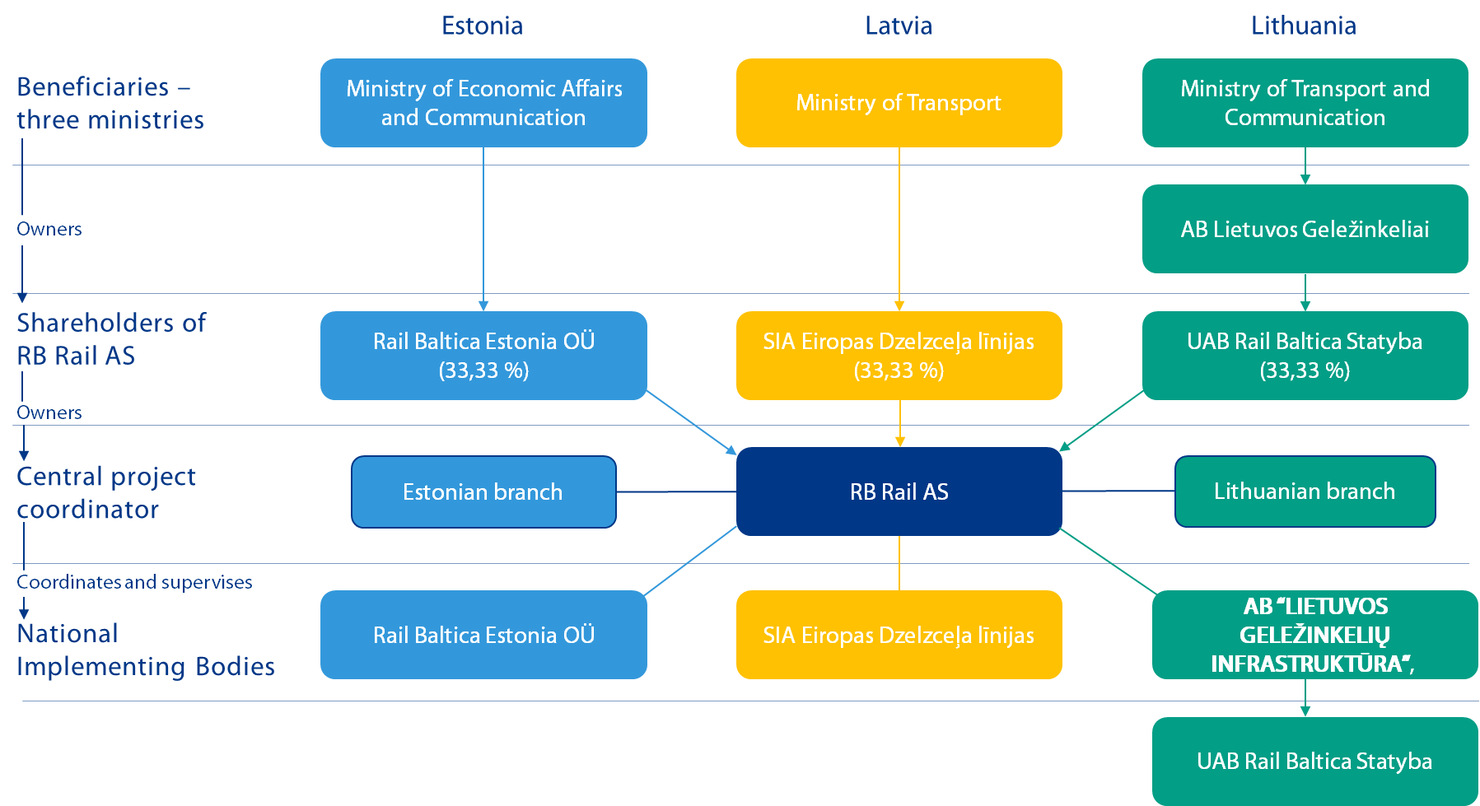
The indicative timeline and phasing of the project implementation can be found here: http://www.railbaltica.org/about-rail-baltica/project-timeline/.

- Procurement subject
  - RBR is appointed to organize the consolidated framework procurement for delivery of railway ballast as part of the railway track infrastructure. This procurement is aimed to ensure deployment of the economically and technically most feasible solutions which meets all Rail Baltica requirements in all three Baltic states (Estonia, Latvia and Lithuania) to maximise the benefits.
  - Unless stated otherwise in the Framework agreement, the scope of supply must be for railway ballast measured in tons delivered to the material/construction site.
  - The railway ballast shall be produced in accordance with Technical specifications provided in Annex 2.2.

- Procurement scope
  - The scope of the procurement is the delivery of ballast as per framework agreement.
  - Ballast supply shall be organized by the Supplier to locations indicated by the Client. Further details regarding delivery requirements will be provided for the second stage to the qualified tenderers. Approximate estimated quantities of railway ballast are following (Table 1):
Lot | Estimated quantities,  m3 and t | Estimated framework value per Lot (EUR without VAT)
Lot No1: Supply of the railway ballast to Tallinn region in Estonia | 665 618 m³  1 098 270 t | 27 456 750
Lot No 2: Supply of the railway ballast to Pärnu region in Estonia | 634 788 m³  1 047 400 t | 26 185 000
Lot No 3: Supply of the railway ballast to Iecava region in Latvia | 676 891 m³  1 116 870 t | 27 921 750
Lot No.4 Supply of the railway ballast to Skulte region in Latvia | 769 806 m³  1 270 180 t | 31 754 500
Lot No 5: Supply of the railway ballast to Panevežys region in Lithuania | 652 630 m³  1 076 840 t | 26 921 000
Lot No 6: Supply of the railway ballast to Kaunas region (Polish border - Kaunas - Vilnius) in Lithuania | 1 492 363 m³  2 462 400 t | 61 560 000
NOTES:
- Estimated quantities in tons are based on assumed bulk density of compacted ballast of 1,65 tons/m³. Final quantity in tons shall be adjusted based on factual particle density of the ballast aggregate.
Precise delivery locations shall be introduced in the Stage Two of the procurement.
Table 1. Estimated quantities and preliminary delivery points for ballast
  - The detailed information on the scope of railway ballast procurement shall be provided in the second stage.

- Indicative delivery timeframe
Contracting Authority is in a design phase, where the construction schedule is in the development, therefore more accurate delivery schedules for the individual lots shall be introduced in the Second Stage of the Procurement. Current plan for the deliveries foresees that railway ballast deliveries will start in 2024. Preliminary forecast delivery schedule by years is as following (Table 2):
Lot and Region \ Year | 2024 | 2025 | 2026 | 2027 +
Lot No 1: Tallinn region |  |  | 833 520 | 264 750
Lot No 2: Pärnu region |  |  | 153 460 | 893 940
Lot No 3: Iecava region |  | 154 290 | 539 840 | 422 740
Lot No 4: Skulte region |  | 71 610 | 867 640 | 330 930
Lot No 5: Panevežys region | 38 950 | 975 000 | 62 890
Lot No 6: Kaunas region (Polish border - Kaunas - Vilnius) | 561 730 | 56 780 | 325 580 | 1 518 310
Table 2. Preliminary forecasted delivery schedule in tons per years
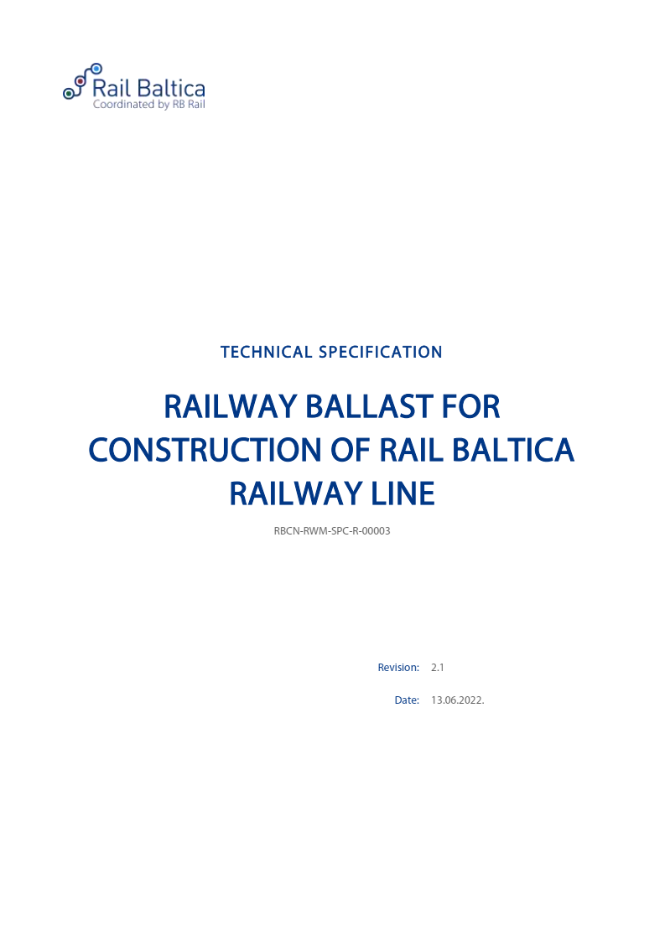
Annex No 2.2
to the Regulation
for competitive procurement procedure
with negotiation No RBR 2022/14
“Consolidated supply of railway ballast for
construction of Rail Baltica railway line”

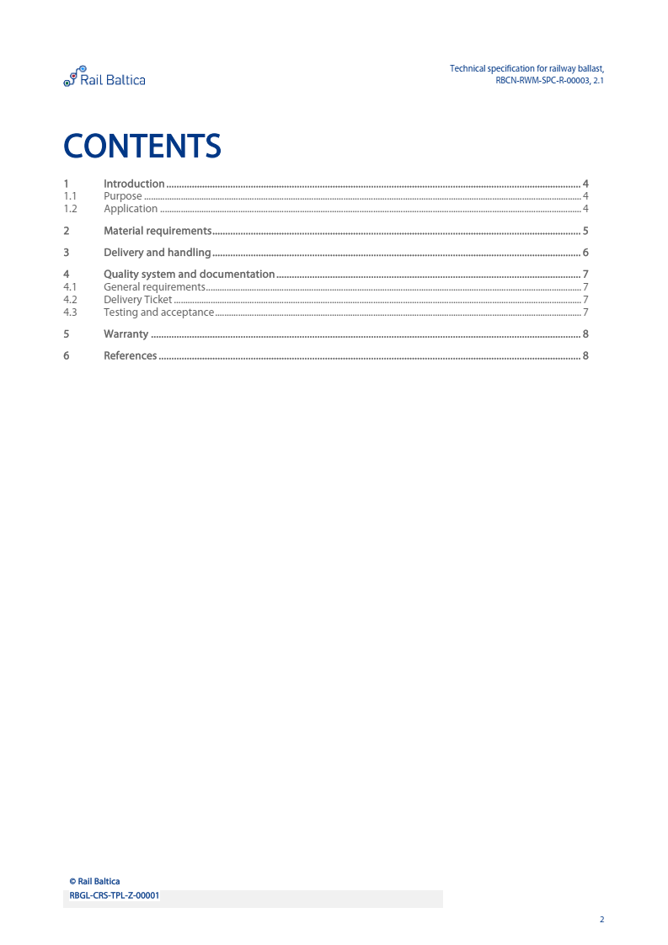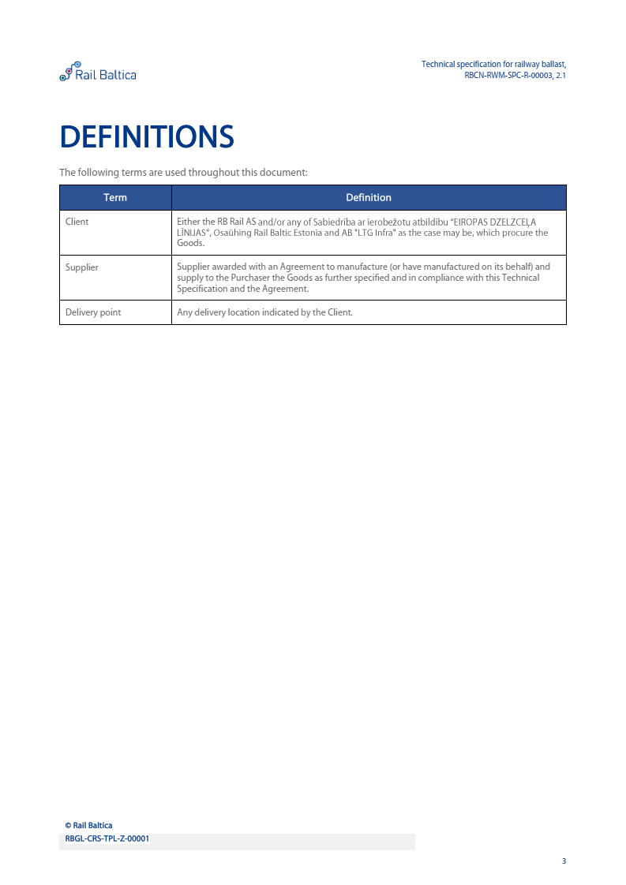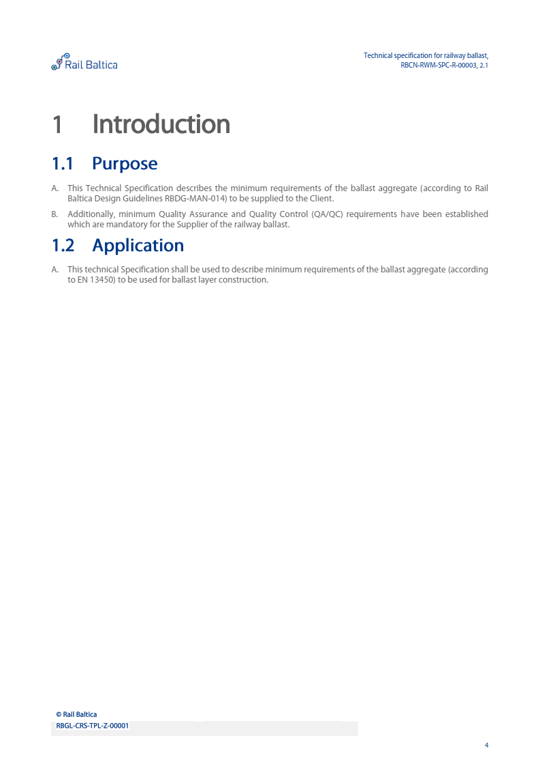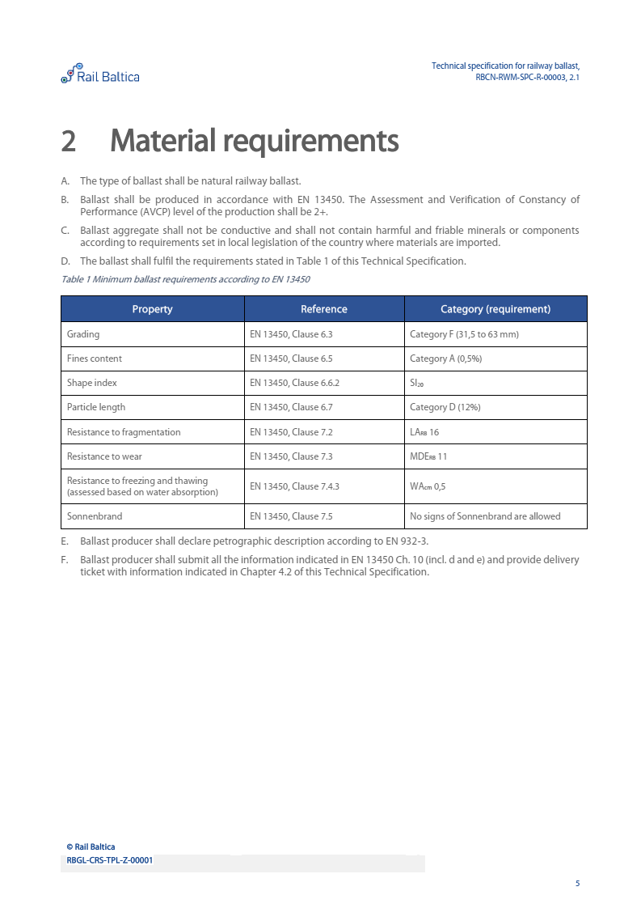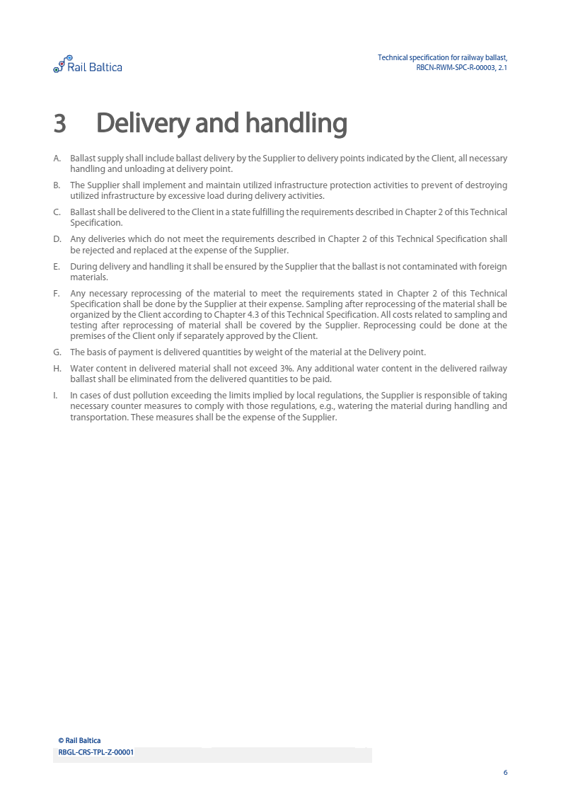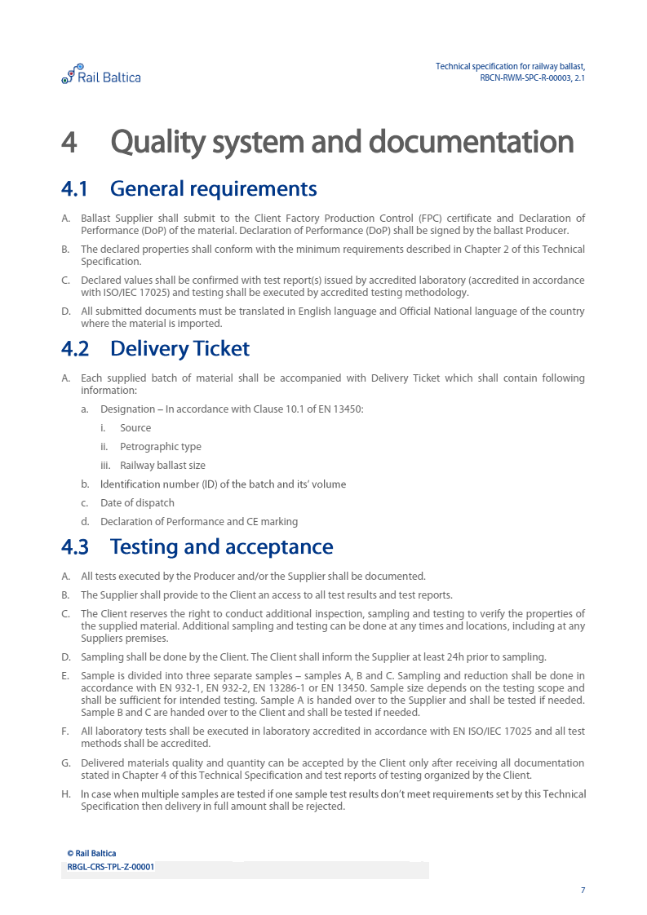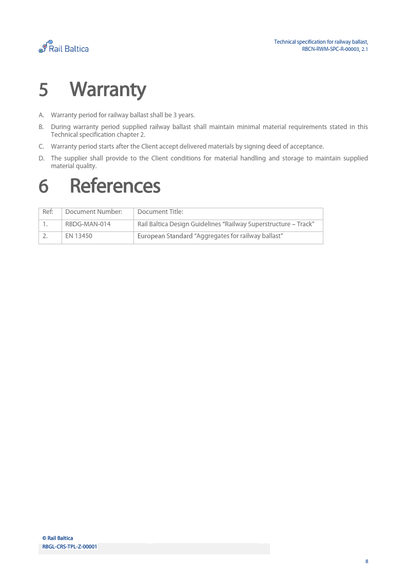

Annex No 3
to the Regulation
for competitive procurement procedure
with negotiation No RBR 2022/14
“Consolidated supply of railway ballast for
construction of Rail Baltica railway line”

Annex No 3: Entities on whose capabilities the Candidate relies to certify its compliance with qualification requirements
No | Name | Description of the capabilities the Candidate relies to certify its compliance with qualification requirements (Section 4.6. of Regulation)
1
2
[..]

Signature [signature of the representative of the Candidate]:______________________________
Date: [date of signing]
Name: [name of the representative of the Candidate]
Position: [position of the representative of the Candidate]

Annex No 4.1.
to the Regulation
for competitive procurement procedure
with negotiation No RBR 2022/14
““Consolidated supply of railway ballast for
construction of Rail Baltica railway line”

Annex No 4.1.: Experience of the Candidate (Lot No 1)
Within the last 5 (five) years before the date of submission of the Application (2021, 2020, 2019, 2018, 2017 and 2022 until the submission of the Application) in any continuous 12 months period the Candidate has performed at least 1 (one) or several contract/-s/ supply/-s of aggregates with all of the following parameters:
- produced in accordance with one or several following standards EN 13450, EN 13043, EN 12620, EN 13242, EN 13285 or equivalent (to prove the required amount of the supply, Candidate may combine several EN standards);
- compatible with CE (Conformité Européenne) marking requirements;
- produced according to AVCP level 2+ as minimum.
for one or several clients for construction of infrastructure projects (roads, earthworks, concrete structures, etc.) for the total amount of 50 000 tons.
No | Client (Contracting authority) | Address, contact person and phone No., e-mail address of the client for references | Description of the supplied aggregates (please indicate standard) | Place of delivery of aggregates (please indicate country/ project) | Delivery date of aggregates (month/year) | Order amount of aggregates (tons) | Compliant with CE (Conformité Européenne) marking requirements (yes/ no) | Produced according to AVCP level 2+ as minimum  (yes/ no)
1.
2.
……
Note: The Candidate shall indicate in the table the experience, which attests compliance with the requirements set in Clause 4.4.1. of the Regulations for the Selection of Candidate

Annex No 4.2.
to the Regulation
for competitive procurement procedure
with negotiation No RBR 2022/14
“Consolidated supply of railway ballast for
construction of Rail Baltica railway line”

Annex No 4.2.: Experience of the Candidate (Lot No 2)
Within the last 5 (five) years before the date of submission of the Application (2021, 2020, 2019, 2018, 2017 and 2022 until the submission of the Application) in any continuous 12 months period the Candidate has performed at least 1 (one) or several contract/-s/ supply/-s of aggregates with all of the following parameters:
- produced in accordance with one or several following standards EN 13450, EN 13043, EN 12620, EN 13242, EN 13285 or equivalent (to prove the required amount of the supply, Candidate may combine several EN standards);
- compatible with CE (Conformité Européenne) marking requirements,
- produced according to AVCP level 2+ as minimum.
for one or several clients for construction of infrastructure projects (roads, earthworks, concrete structures, etc.) for the total amount of 50 000 tons.
No | Client (Contracting authority) | Address, contact person and phone No., e-mail address of the client for references | Description of the supplied aggregates (please indicate standard) | Place of delivery of aggregates (please indicate country/ project) | Delivery date of aggregates (month/year) | Order amount of aggregates (tons) | Compliant with CE (Conformité Européenne) marking requirements (yes/ no) | Produced according to AVCP level 2+ as minimum  (yes/ no)
1.
2.
……

Note: The Candidate shall indicate in the table the experience, which attests compliance with the requirements set in Clause 4.4.1. of the Regulations for the Selection of Candidates.
Annex No 4.3.
to the Regulation
for competitive procurement procedure
with negotiation No RBR 2022/14
“Consolidated supply of railway ballast for
construction of Rail Baltica railway line”

Annex No 4.3.: Experience of the Candidate (Lot No 3)
Within the last 5 (five) years before the date of submission of the Application (2021, 2020, 2019, 2018, 2017 and 2022 until the submission of the Application) in any continuous 12 months period the Candidate has performed at least 1 (one) or several contract/-s/ supply/-s of aggregates with all of the following parameters:
- produced in accordance with one or several following standards EN 13450, EN 13043, EN 12620, EN 13242, EN 13285 or equivalent (to prove the required amount of the supply, Candidate may combine several EN standards);
- compatible with CE (Conformité Européenne) marking requirements,
- produced according to AVCP level 2+ as minimum.
for one or several clients for construction of infrastructure projects (roads, earthworks, concrete structures, etc.) for the total amount of 50 000 tons.
No | Client (Contracting authority) | Address, contact person and phone No., e-mail address of the client for references | Description of the supplied aggregates (please indicate standard) | Place of delivery of aggregates (please indicate country/ project) | Delivery date of aggregates (month/year) | Order amount of aggregates (tons) | Compliant with CE (Conformité Européenne) marking requirements (yes/ no) | Produced according to AVCP level 2+ as minimum  (yes/ no)
1.
2.
……
Note: The Candidate shall indicate in the table the experience, which attests compliance with the requirements set in Clause 4.4.1. of the Regulations for the Selection of Candidates.
Annex No 4.4.
to the Regulation
for competitive procurement procedure
with negotiation No RBR 2022/14
“Consolidated supply of railway ballast for
construction of Rail Baltica railway line”

Annex No 4.4.: Experience of the Candidate (Lot No 4)
Within the last 5 (five) years before the date of submission of the Application (2021, 2020, 2019, 2018, 2017 and 2022 until the submission of the Application) in any continuous 12 months period the Candidate has performed at least 1 (one) or several contract/-s/ supply/-s of aggregates with all of the following parameters:
- produced in accordance with one or several following standards EN 13450, EN 13043, EN 12620, EN 13242, EN 13285 or equivalent (to prove the required amount of the supply, Candidate may combine several EN standards);
- compatible with CE (Conformité Européenne) marking requirements,
- produced according to AVCP level 2+ as minimum.
for one or several clients for construction of infrastructure projects (roads, earthworks, concrete structures, etc.) for the total amount of 50 000 tons.
No | Client (Contracting authority) | Address, contact person and phone No., e-mail address of the client for references | Description of the supplied aggregates (please indicate standard) | Place of delivery of aggregates (please indicate country/ project) | Delivery date of aggregates (month/year) | Order amount of aggregates (tons) | Compliant with CE (Conformité Européenne) marking requirements (yes/ no) | Produced according to AVCP level 2+ as minimum  (yes/ no)
1.
2.
……
Note: The Candidate shall indicate in the table the experience, which attests compliance with the requirements set in Clause 4.4.1. of the Regulations for the Selection of Candidates.

Annex No 4.5.
to the Regulation
for competitive procurement procedure
with negotiation No RBR 2022/14
“Consolidated supply of railway ballast for
construction of Rail Baltica railway line”

Annex No 4.5.: Experience of the Candidate (Lot No 5)
Within the last 5 (five) years before the date of submission of the Application (2021, 2020, 2019, 2018, 2017 and 2022 until the submission of the Application) in any continuous 12 months period the Candidate has performed at least 1 (one) or several contract/-s/ supply/-s of aggregates with all of the following parameters:
- produced in accordance with one or several following standards EN 13450, EN 13043, EN 12620, EN 13242, EN 13285 or equivalent (to prove the required amount of the supply, Candidate may combine several EN standards);
- compatible with CE (Conformité Européenne) marking requirements,
- produced according to AVCP level 2+ as minimum.
for one or several clients for construction of infrastructure projects (roads, earthworks, concrete structures, etc.) for the total amount of 50 000 tons.
No | Client (Contracting authority) | Address, contact person and phone No., e-mail address of the client for references | Description of the supplied aggregates (please indicate standard) | Place of delivery of aggregates (please indicate country/ project) | Delivery date of aggregates (month/year) | Order amount of aggregates (tons) | Compliant with CE (Conformité Européenne) marking requirements (yes/ no) | Produced according to AVCP level 2+ as minimum  (yes/ no)
1.
2.
……

Note: The Candidate shall indicate in the table the experience, which attests compliance with the requirements set in Clause 4.4.1. of the Regulations for the Selection of Candidates.

Annex No 4.6.
to the Regulation
for competitive procurement procedure
with negotiation No RBR 2022/14
“Consolidated supply of railway ballast for
construction of Rail Baltica railway line”

Annex No 4.6.: Experience of the Candidate (Lot No 6)
Within the last 5 (five) years before the date of submission of the Application (2021, 2020, 2019, 2018, 2017 and 2022 until the submission of the Application) in any continuous 12 months period the Candidate has performed at least 1 (one) or several contract/-s/ supply/-s of aggregates with all of the following parameters:
- produced in accordance with one or several following standards EN 13450, EN 13043, EN 12620, EN 13242, EN 13285 or equivalent (to prove the required amount of the supply, Candidate may combine several EN standards);
- compatible with CE (Conformité Européenne) marking requirements,
- produced according to AVCP level 2+ as minimum.
for one or several clients for construction of infrastructure projects (roads, earthworks, concrete structures, etc.) for the total amount of 100 000 tons.
No | Client (Contracting authority) | Address, contact person and phone No., e-mail address of the client for references | Description of the supplied aggregates (please indicate standard) | Place of delivery of aggregates (please indicate country/ project) | Delivery date of aggregates (month/year) | Order amount of aggregates (tons) | Compliant with CE (Conformité Européenne) marking requirements (yes/ no) | Produced according to AVCP level 2+ as minimum  (yes/ no)
1.
2.
……
Note: The Candidate shall indicate in the table the experience, which attests compliance with the requirements set in Clause 4.4.1. of the Regulations for the Selection of Candidates.

Annex No 5
to the Regulation
for competitive procurement procedure with negotiation No RBR 2022/14
“Consolidated supply of railway ballast for
construction of Rail Baltica railway line”

Annex No 5: Confirmation of Candidates Financial Standing
Section 4.3.: The Candidate’s average financial turnover within the last 3 (three) financial years (2019, 2020, 2021) is not less than:
- 10 000 000 EUR if the Candidate applies for the Lot No 1;
- 10 000 000 EUR if the Candidate applies for the Lot No 2;
- 10 000 000 EUR if the Candidate applies for the Lot No 3;
- 10 000 000 EUR if the Candidate applies for the Lot No 4;
- 10 000 000 EUR if the Candidate applies for the Lot No 5;
- 20 000 000 EUR if the Candidate applies for the Lot No 6.
If the Candidate is a partnership (consortium), the turnover of all members of a partnership together shall comply with the above requirement for each lot.If the Candidate applies for several lots, the Candidate’s or all members’ of the partnership together (if the Candidate is a partnership), average financial turnover within the last 3 (three) financial years (2019, 2020, 2021) is not less than sum of average financial turnover values set for each lot for which the Candidate has applied by submitting application.
No | Year | Total Turnover in EUR* | Notes
Candidate or member of the partnership (if the Candidate is a partnership)
1
2
3
Average within last 3 (three) financial years
If the Candidate is partnership, please continue and provide info regarding each member and partnership in total.
1
2
3
________________________________________
Name of the Candidate/member of partnership/entity *If the financial turnover is in another currency than euro, for the purposes of this Application it should be recalculated in euro in accordance with the currency exchange rate published by the European Central Bank on the date of signing of this document

If the Candidate submits the European Single Procurement Document as the initial proof, there is no obligation to submit other documents, unless specifically requested by the procurement commission.
Offshore: low tax or tax-free country or territory in accordance with Corporate income tax law of the Republic of Latvia except Member States of EEA (European Economic Area) or its territories, Member States of the World Trade Organization Agreement on State Treaties or territories and such countries and territories with which European Union and Republic of Latvia has international agreements for open market in public procurement area.
^{[1]} Beneficial owner: a natural person who is the owner of the customer - legal person - or who controls the customer, or on whose behalf, for whose benefit or in whose interests business relationship is being established or an individual transaction is being executed, and it is at least: a) regarding legal persons - a natural person who owns, in the form of direct or indirect shareholding, more than 25 per cent of the capital shares or voting stock of the legal person or who directly or indirectly controls it; b) regarding legal arrangements - a natural person who owns or in whose interests a legal arrangement has been established or operates, or who directly or indirectly exercises control over it, including who is the founder, proxy or supervisor (manager) of such legal arrangement.
If a Candidate is a partnership, members of the partnership together shall comply with the above requirements.
Assessment and Verification of Constancy of Performance
The information on the size of the Candidate is used solely for statistical purposes and is not in any way whatsoever used in the evaluation of the Candidate or the Application.
Available here - http://eur-lex.europa.eu/legal-content/EN/TXT/?uri=uriserv:OJ.L_.2003.124.01.0036.01.ENG&toc=OJ:L:2003:124:TOC
The information on the size of the Candidate is used solely for statistical purposes and is not in any way whatsoever used in the evaluation of the Candidate or the Application.
Available here - http://eur-lex.europa.eu/legal-content/EN/TXT/?uri=uriserv:OJ.L_.2003.124.01.0036.01.ENG&toc=OJ:L:2003:124:TOC
The information on the size of the Candidate is used solely for statistical purposes and is not in any way whatsoever used in the evaluation of the Candidate or the Application.
Available here - http://eur-lex.europa.eu/legal-content/EN/TXT/?uri=uriserv:OJ.L_.2003.124.01.0036.01.ENG&toc=OJ:L:2003:124:TOC
The information on the size of the Candidate is used solely for statistical purposes and is not in any way whatsoever used in the evaluation of the Candidate or the Application.
Available here - http://eur-lex.europa.eu/legal-content/EN/TXT/?uri=uriserv:OJ.L_.2003.124.01.0036.01.ENG&toc=OJ:L:2003:124:TOC
The information on the size of the Candidate is used solely for statistical purposes and is not in any way whatsoever used in the evaluation of the Candidate or the Application.
Available here - http://eur-lex.europa.eu/legal-content/EN/TXT/?uri=uriserv:OJ.L_.2003.124.01.0036.01.ENG&toc=OJ:L:2003:124:TOC
The information on the size of the Candidate is used solely for statistical purposes and is not in any way whatsoever used in the evaluation of the Candidate or the Application.
Available here - http://eur-lex.europa.eu/legal-content/EN/TXT/?uri=uriserv:OJ.L_.2003.124.01.0036.01.ENG&toc=OJ:L:2003:124:TOC
Assessment and Verification of Constancy of Performance
Assessment and Verification of Constancy of Performance
Assessment and Verification of Constancy of Performance
Assessment and Verification of Constancy of Performance
Assessment and Verification of Constancy of Performance
Assessment and Verification of Constancy of Performance

